**Reconfigurable Silicon-Photonic Auto-Regressive Moving Average Filter**

Matan Slook1,2, Saawan Kumar Bag1, Leroy Dokhanian1,2, Shai Ben-Ami1, Maayan Holsblat1, and Avi Zadok1,2,*

1Faculty of Engineering and Institute of Nano-Technology and Advanced Materials, Bar-Ilan University, Ramat-Gan 5290002, Israel

2Presently with the Faculty of Electrical and Computer Engineering, the Technion – Israel Institute of Technology, Haifa 3200003, Israel

* [Avi.Zadok@technion.ac.il](mailto:Avi.Zadok@technion.ac.il)

**Abstract:** A reconfigurable silicon photonic filter with four ring resonators nested in a Mach-Zehnder interferometer is demonstrated. Multiple transfer functions are realized through thermal adjustment of phase delays, including sharp variable width filters and narrow passbands. © 2024 The Authors.

1. Introduction

Photonic integrated filters can process signals of ultra-broad bandwidths. Like digital filters, the response of many photonic filters is discrete in time [1]. Filters may be broadly classified as moving average designs, which include feed-forward paths only, and auto-regressive layouts constructed of feedback paths. The transfer function of the former category is described by the locations of zeros in the complex -domain, whereas that of the latter is governed by locations of poles [1]. The basic building blocks of photonic integrated moving average and auto-regressive filters are Mach-Zehnder interferometers and ring resonator waveguides, respectively. Filters combining both zeros and poles are referred to as auto-regressive moving-average (ARMA) devices. ARMA filters provide larger design freedom, and their frequency response can exhibit sharp transitions between pass and stop bands [1,2]. Photonic integrated ARMA filters can be realized using Mach-Zehnder interferometers with one or more ring resonators nested in one or both arms [1]. The response of photonic integrated filters may be modified through local heating elements, based on the thermo-optic effect [ref.].

In this work we report a reconfigurable, silicon-photonic filter stage, comprised of a balanced Mach-Zehnder interferometer with two ring resonators nested in each arm. The optical phase delay in each of the four rings, and the differential phase delay of the Mach-Zehnder interferometer, may be adjusted independently by driving current through five metallic heater elements. The transfer function of optical power through the filter stage can be tuned to various forms of interest, including a sharp and uniform bandpass filters of variable widths and a sub-GHz narrow passband.

2. Results

A schematic illustration of the reconfigurable silicon photonic filter is shown in Fig. 1(a). A Mach-Zehnder interferometer is formed between two 50/50 directional couplers. The upper arm of the interferometer is coupled to two ring resonator waveguides 1,2 in series, and the lower arm is similarly coupled to ring resonators 3 and 4. We denote the transmission of the optical field to the through port of the directional coupler leading to resonator as (see Fig. 1(a)). The round-trip group delays of all four resonators equal the same .

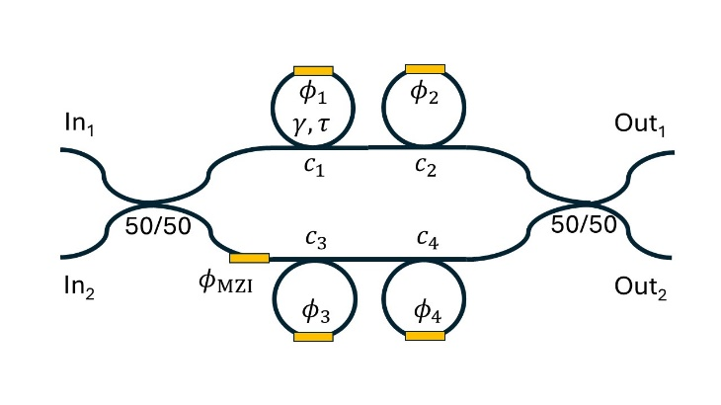 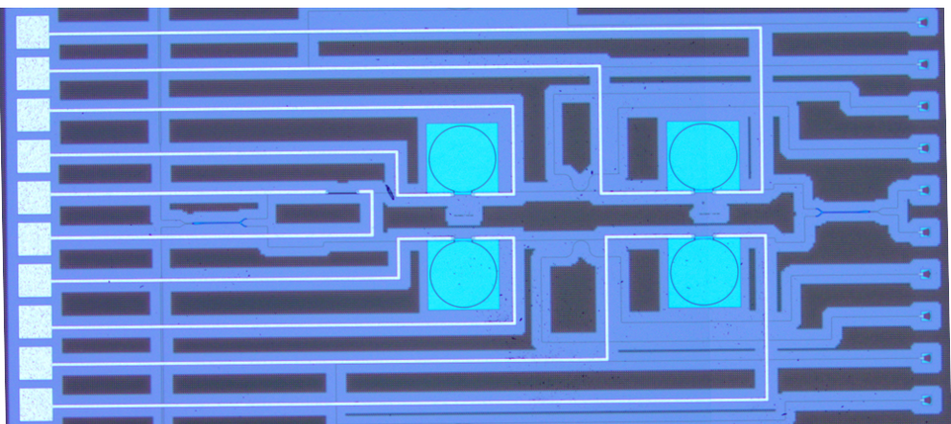

(b)

(a)

Fig. 1. (a): Schematic illustration of the reconfigurable silicon-photonic filter. (b): Top-view optical microscope image of the fabricated device.

The Z-domain transfer matrix between the two input ports of the filter and its two output ports is given by [1]:



Here denotes the round-trip phase delay in resonator and is the differential phase delay between the two arms of the Mach-Zehnder interferometer. is the round-trip attenuation of the optical field, assumed to be equal for all resonators, While the couplers parameters are fixed, all five phases and may be adjusted through thermo-optic tuning. The transfer functions of optical power vary with the choices of all phases. Here and denotes normalized frequency.

Devices were fabricated on a silicon-on-insulator wafer by AMF… A top-view microscope image of the device is shown in Fig. 1(b). The radii of all ring resonators are 100 µm, corresponding to = ps. The couplers parameters were and . The round trip attenuation was measured as . Light was coupled between standard single-mode fibers and the input and output ports of the device using vertical grating couplers. The coupling efficiency was 7.5 dB per facet. DC voltages from tunable power supplied were applied to each of the five heating elements through five pairs of metallic contact pads. The transfer functions of optical power were monitored using an optical vector network analyzer, with a spectral resolution of 3 pm.

Figure 2 shows examples of normalized transfer functions as functions of wavelength . Panel 2(a) presents sharp periodic bandpass filters, with a free spectral range of 1 nm. The duty cycle of the transmission passbands could be varied between 0.25-0.5. Out of band rejection was better than dB, and the transitions bandwidth between pass and stop bands was nm. The residual in-band nonuniformity of the 0.5 duty cycle filter was dB. The transfer functions agree with modelling. For example, the 0.5 duty cycle transmission is predicted for phases = 0.88π, = -0.35π, = -0.88π, = 0.35π, and = 0.5π. Figure 2(b) shows a narrow passband, with full width at half maximum of only 6.5 pm. The bandwidth corresponds to a quality factor of 250,000, 2.5 times higher than that of a single resonator in the same platform. Figures 2(c) and 2(d) present additional examples of transfer functions obtained through the tuning of phases: periodic transmission notched with nm bandwidth, and a Mach-Zehnder interferometer-like response. The results demonstrate the broad range of reconfiguration supported by the filter.

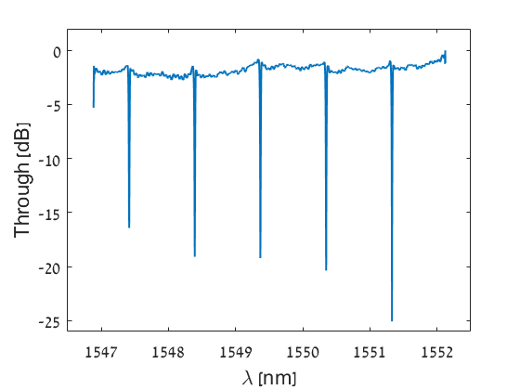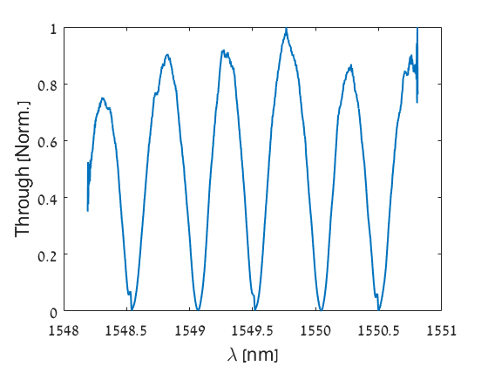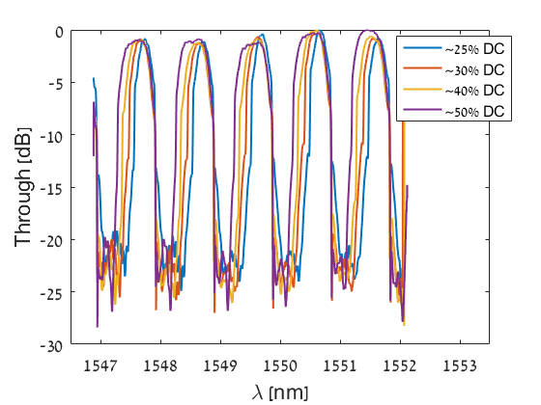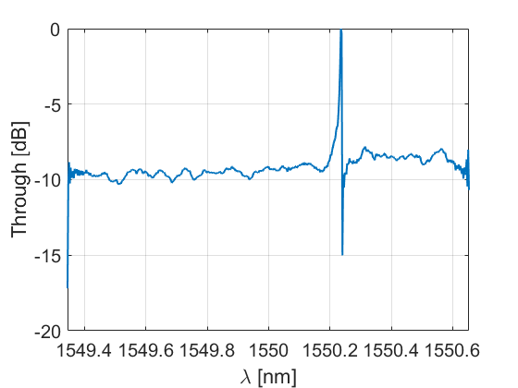

(a)

(b)

(c)

(d)

Fig. 2. Measured normalized transfer functions of optical power through a reconfigurable silicon-photonic filter. (a): Bandpass filters of variable duty cycles. (b): Periodic narrow passbands. (c): Periodic transmission notches. (d): Mach-Zehnder interferometer-like response.

References

1. C. K. Madsen and J. H. Zhao, *Optical Filter Design and Analysis – A Signal Processing Approach* (Wiley, 1999).
2. D. Munk, M. Katzman, Y. Kaganovskii, N. Inbar, A. Misra, M. Hen, M. Priel, M. Feldberg, M. Tkachev, A. Bergman, M. Vofsi, M. Rosenbluh, T. Schneider, and A. Zadok, "Eight-Channel Silicon-Photonic Wavelength Division Multiplexer With 17 GHz Spacing," IEEE J. Selected Topics Quantum Electron. **25**, 8300310 (2019).